COVID-19 FOOD, WATER AND SURFACE TRANSMISSION
Can the coronavirus spread through food?
Coronaviruses are generally thought to be spread from person to person through respiratory droplets. Currently, there is no evidence to support transmission of COVID-19 associated with food. Before preparing or eating food it is important to always wash your hands with soap and water for at least 20 seconds for general food safety.
Can you get coronavirus from touching food packaging, food or contaminated surfaces?
Currently there is no evidence of food or food packaging being associated with transmission of COVID-19.
Can the virus that causes COVID-19 spread through drinking water?
The virus that causes COVID-19 has not been detected in drinking water. Conventional water treatment methods that use filtration and disinfection, such as those in most municipal drinking water systems, should remove or inactivate the virus that causes COVID-19.
Can the COVID-19 virus spread through sewerage systems?
The virus that causes COVID-19 has been found in untreated wastewater. Researchers do not know whether this virus can cause disease if a person is exposed to untreated wastewater or sewerage systems. There is no evidence to date that this has occurred. At this time, the risk of transmission of the virus that causes COVID-19 through properly designed and maintained sewerage systems is thought to be low. Researchers have analyzed the available information which suggest that standard municipal and individual septic system wastewater treatment practices should inactivate the virus that causes COVID-19. CDC is reviewing information on COVID-19 transmission as it becomes available. Guidance will be updated as new evidence is assessed.
Can you contract the coronavirus disease by touching a surface?
It may be possible that a person can get COVID-19 by touching a surface or object that has the virus on it and then touching their own mouth, nose, or possibly their eyes, but this is not thought to be the main way the virus spreads.
How long does the coronavirus live on surfaces?
Current evidence suggests that novel coronavirus may remain viable for hours to days on surfaces made from a variety of materials. Cleaning of visibly dirty surfaces followed by disinfection is a best practice measure for prevention of COVID-19 and other viral respiratory illnesses in households and community settings.
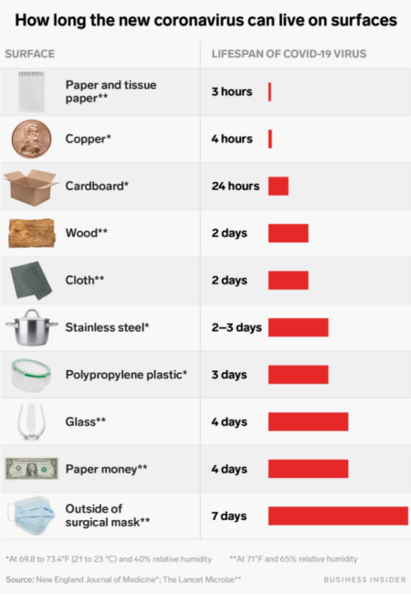
Source: www.cdc.gov

